实验9 数据库应用

实验类型：设计性实验 要求：必做 学时：4

**一、实验目的**

1、掌握数据库应用的基本方法。

2、掌握将查询结果表与数据集绑定，并在相应控件上同步显示查询结果的方法。

**二、实验内容**

1、连接数据库。

2、在线访问数据库。

3、离线访问数据库。

**三、实验步骤**

1、在using语句块中打开数据库连接，并显示连接状态。可参考教材P278。

关键代码如下：

using System.Data.SqlClient;

namespace sy9_1

{

public partial class Form1 : Form

{

public Form1()

{

InitializeComponent();

}

private void button1_Click(object sender, EventArgs e)

{

string strcon = @"Data Source=shfomen7\sqlexpress;Initial Catalog=XSCJDB;Integrated Security=True";

SqlConnection sqlConnection;

using (sqlConnection = new SqlConnection(strcon))

{

sqlConnection.Open();

MessageBox.Show("数据库连接状态：" + sqlConnection.State.ToString());

}

MessageBox.Show("数据库连接状态：" + sqlConnection.State.ToString());

}

}

}

运行结果截图如下：

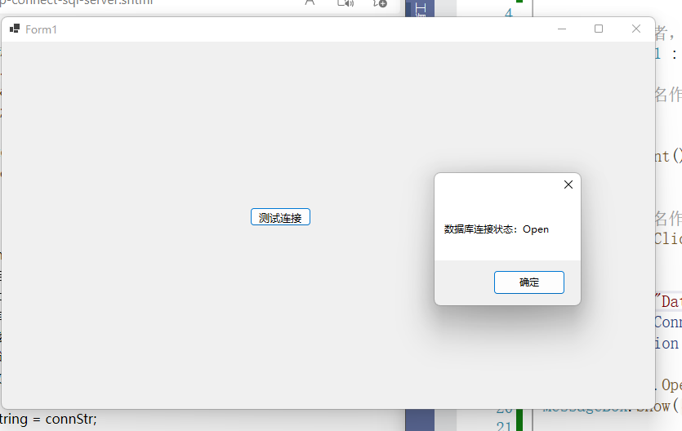

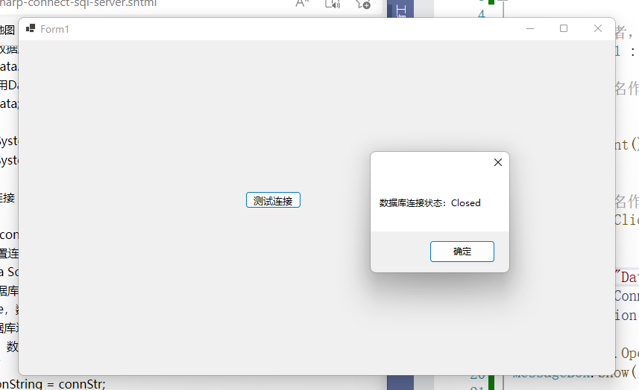using System.Data.SqlClient;

namespace sy9_1

{

public partial class Form1 : Form

{

public Form1()

{

InitializeComponent();

}

private void button1_Click(object sender, EventArgs e)

{

string strcon = @"Data Source=shfomen7\sqlexpress;Initial Catalog=XSCJDB;Integrated Security=True";

SqlConnection sqlConnection;

using (sqlConnection = new SqlConnection(strcon))

{

sqlConnection.Open();

MessageBox.Show("数据库连接状态：" + sqlConnection.State.ToString());

}

MessageBox.Show("数据库连接状态：" + sqlConnection.State.ToString());

}

}

}

2、利用Command对象和DataReader对象相互配合的方式，在线访问XSCJDB数据库。

要求：能实现学生记录的添加和实时查看功能。界面设计效果如下图所示：

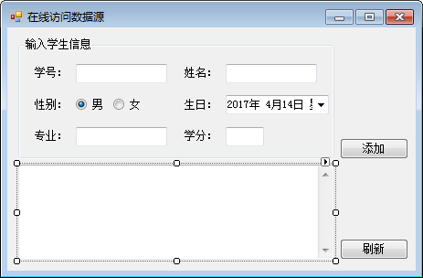

关键代码如下：

using System.Data;

using System.Data.SqlClient;

namespace sy9_2

{

public partial class Form1 : Form

{

string strcon = @"Data Source=shfomen7\sqlexpress;Initial Catalog=XSCJDB;Integrated Security=True";

SqlConnection sqlConnection;

public Form1()

{

InitializeComponent();

display();

}

private void Form1_Load(object sender, EventArgs e)

{

}

private void display()

{

textBox3.Clear();

using (sqlConnection = new SqlConnection(strcon))

{

sqlConnection.Open();

string sql = "select * from xsb";

SqlCommand command = new SqlCommand(sql, sqlConnection);

SqlDataReader reader = command.ExecuteReader();

if (reader.HasRows)

{

while (reader.Read())

{

textBox3.Text += reader[0].ToString() + "\t\t" + reader[1].ToString() + "\t\t" + reader[2].ToString() + "\t\t" + reader[3].ToString().Split(" ")[0] + " \t\t" + reader[4].ToString() + "\t\t" + reader[5].ToString() + "\r\n";

}

}

reader.Close();

}

}

private void button1_Click(object sender, EventArgs e)

{

SqlConnection sqlcon = new SqlConnection(strcon);

try

{

string id = textBox1.Text.Trim();

string name = textBox2.Text.Trim();

string xb;

if (radioButton1.Checked)

{

xb = "男";

}

else

{

xb = "女";

}

string birthday = dateTimePicker1.Value.ToShortDateString().Split(" ")[0];

string major = textBox4.Text.Trim();

string credit = textBox5.Text.Trim();

SqlCommand command = new SqlCommand();

command.CommandText = "insert into xsb(XH,XM,XB,CSRQ,ZY,ZXF) VALUES('" + id + "','" + name + "','" + xb + "','" + birthday + "','" + major + "','" + credit + "')";

command.CommandType = CommandType.Text;

command.Connection = sqlcon;

sqlcon.Open();

if (command.ExecuteNonQuery()==1)

{

MessageBox.Show("插入成功!");

display();

}

}

catch (Exception exception)

{

MessageBox.Show(exception.Message);

}

finally

{

sqlcon.Close();

}

}

}

}

运行结果截图如下：

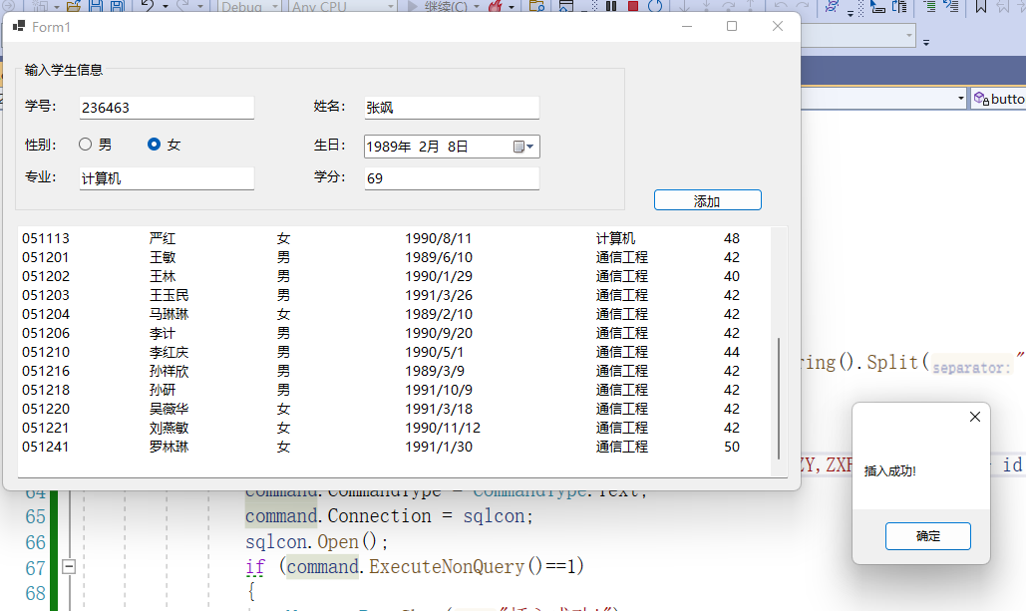

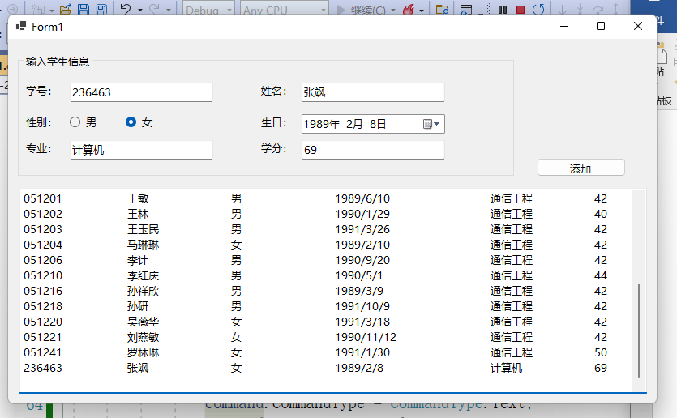

3、使用DataAdapter对象填充DataSet的方法，离线访问XSCJDB数据库。界面设计效果及功能要求同上一题。

关键代码如下：

using System.Data;

using System.Data.SqlClient;

namespace sy9_3

{

public partial class Form1 : Form

{

string strcon = @"Data Source=shfomen7\sqlexpress;Initial Catalog=XSCJDB;Integrated Security=True";

DataSet myst = new DataSet();

private SqlConnection sqlConnection;

private SqlDataAdapter myda;

public Form1()

{

InitializeComponent();

display();

}

private void Form1_Load(object sender, EventArgs e)

{

}

private void display()

{

using (sqlConnection = new SqlConnection(strcon))

{

sqlConnection.Open();

string sql = "select * from xsb";

SqlCommand command = new SqlCommand(sql, sqlConnection);

myda = new SqlDataAdapter(command);

myst.Tables.Clear();

myda.Fill(myst, "xsb");

dataGridView1.DataSource = myst.Tables["xsb"];

}

}

private void button1_Click(object sender, EventArgs e)

{

SqlConnection sqlcon = new SqlConnection(strcon);

try

{

string id = textBox1.Text.Trim();

string name = textBox2.Text.Trim();

string xb;

if (radioButton1.Checked)

{

xb = "男";

}

else

{

xb = "女";

}

string birthday = dateTimePicker1.Value.ToShortDateString().Split(" ")[0];

string major = textBox4.Text.Trim();

string credit = textBox5.Text.Trim();

SqlCommand command = new SqlCommand();

command.CommandText = "insert into xsb(XH,XM,XB,CSRQ,ZY,ZXF) VALUES('" + id + "','" + name + "','" + xb + "','" + birthday + "','" + major + "','" + credit + "')";

command.CommandType = CommandType.Text;

command.Connection = sqlcon;

sqlcon.Open();

myda = new SqlDataAdapter(command);

myda.Fill(myst, "xsb");

MessageBox.Show("插入成功!");

display();

}

catch (Exception exception)

{

MessageBox.Show(exception.Message);

}

finally

{

sqlcon.Close();

}

}

}

}

运行结果截图如下：

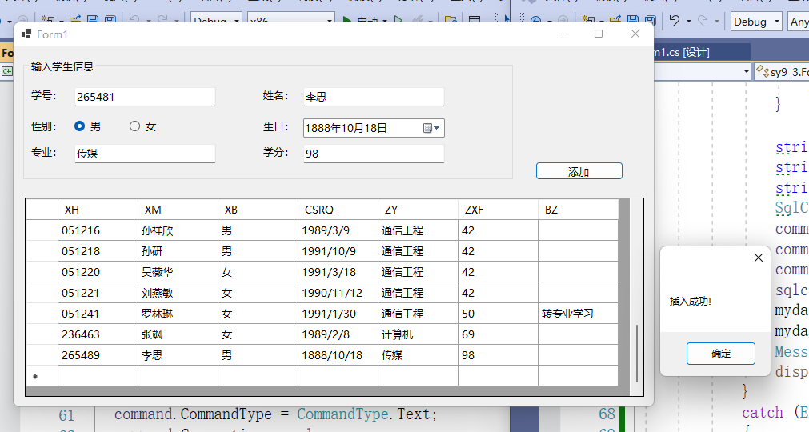

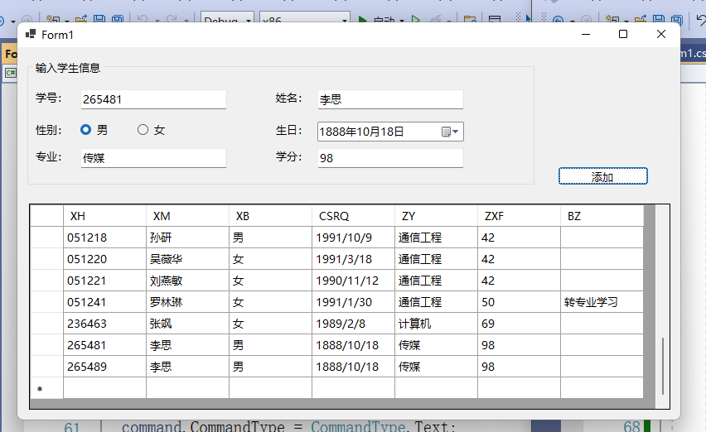

**四、实验小结**

通过本次实验我学会使用ADO.NET通过C#来操作数据库，使用Connection对象连接数据库，使用Command对象执行sql语句，使用DataReader对象读取数据。使用DataAdapter适配器对象对数据的离线访问。

**五、实验提交**

把本文档以学号姓名sy9为名(形如019301784160张三sy9)保存后提交到指定的ftp处。